🌐 AWS LAB EXERCISE
EC2 + Load Balancer + Domain + Route 53

🎯 Objective
- Create 2 EC2 instances
- Install Apache (httpd)
- Configure Application Load Balancer
- Map domain using:
  - Direct DNS (GoDaddy/Hostinger)
  - Amazon Route 53
- Access website via:
  - Public IP
  - Domain
  - Load Balancer DNS

📌 Naming Convention
Resource | Name
EC2 Instance 1 | studentname-ec2-1
EC2 Instance 2 | studentname-ec2-2
Security Group | studentname-sg
Load Balancer | studentname-alb
Target Group | studentname-tg
Hosted Zone | studentname.com

🧪 PART 1: Create EC2 Instances
Step 1: Launch 2 EC2 Instances
Go to → Amazon EC2
Create:
- studentname-ec2-1
- studentname-ec2-2
Config:
- AMI: Amazon Linux 2
- Instance Type: t2.micro
- Same VPC & Subnet
- Security Group: studentname-sg

Step 2: Security Group Rules
Allow:
- SSH (22) → Your IP
- HTTP (80) → Anywhere
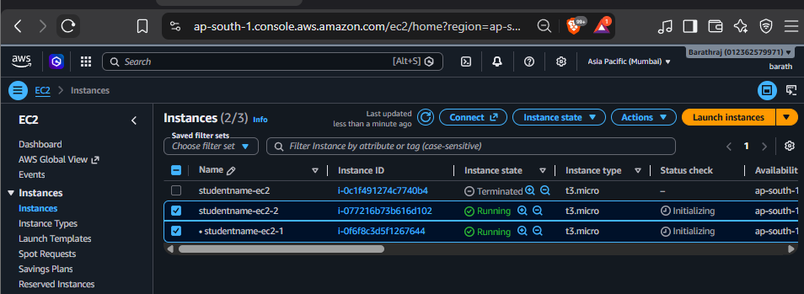

Step 3: Install Apache on BOTH Instances
SSH into each instance and run:
sudo yum update -y
sudo yum install httpd -y
sudo systemctl start httpd
sudo systemctl enable httpd
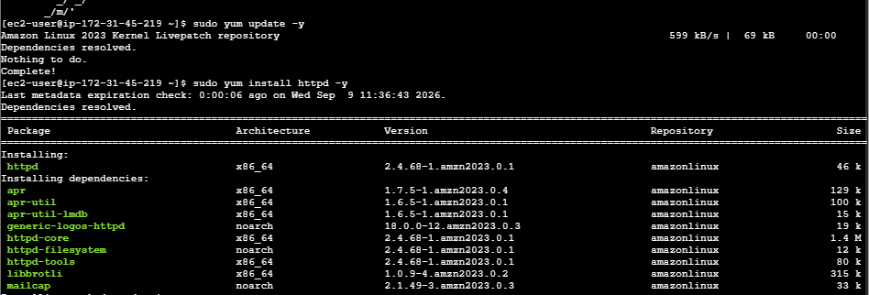

Step 4: Create Unique Web Pages
EC2-1:
echo "<h1>Server 1 - studentname</h1>" | sudo tee /var/www/html/index.html
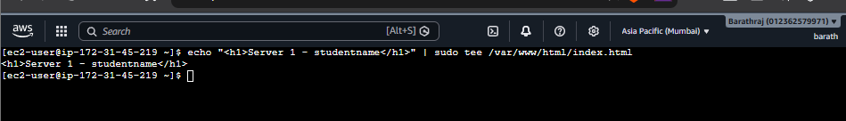
EC2-2:
echo "<h1>Server 2 - studentname</h1>" | sudo tee /var/www/html/index.html
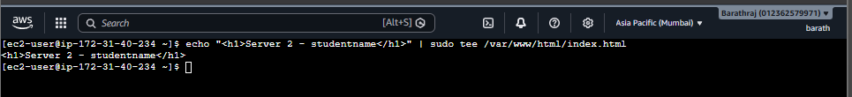

Step 5: Test via Public IP
Open browser:
http://<EC2-1-PUBLIC-IP>
http://<EC2-2-PUBLIC-IP>
✅ Each should show different output
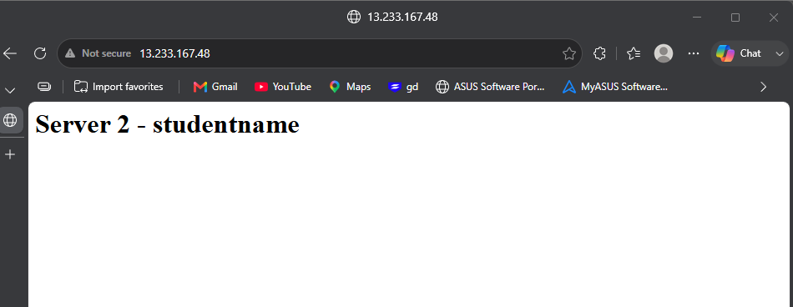
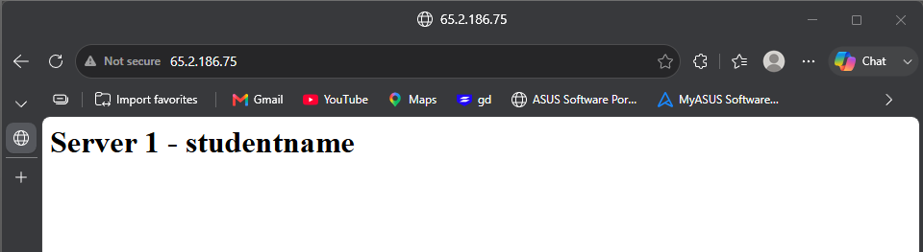

⚖️ PART 2: Create Load Balancer
Step 6: Create Target Group
Go to → EC2 → Target Groups
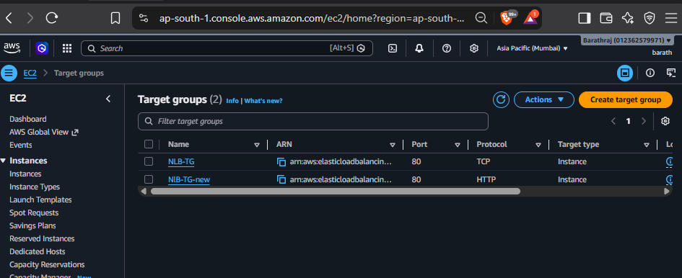
- Name: studentname-tg
- Type: Instances
- Protocol: HTTP
- Port: 80
Register:
- studentname-ec2-1
- studentname-ec2-2
- 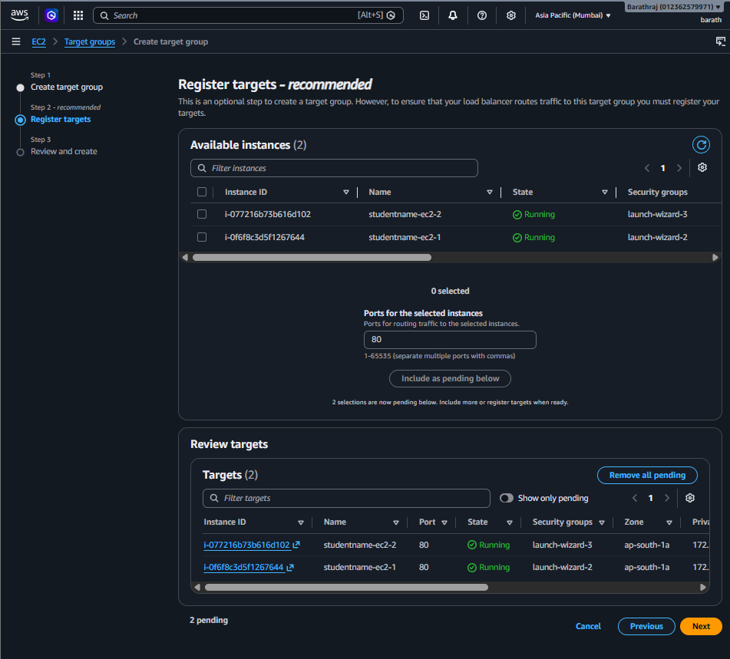

Step 7: Create Load Balancer
Go to → EC2 → Load Balancers
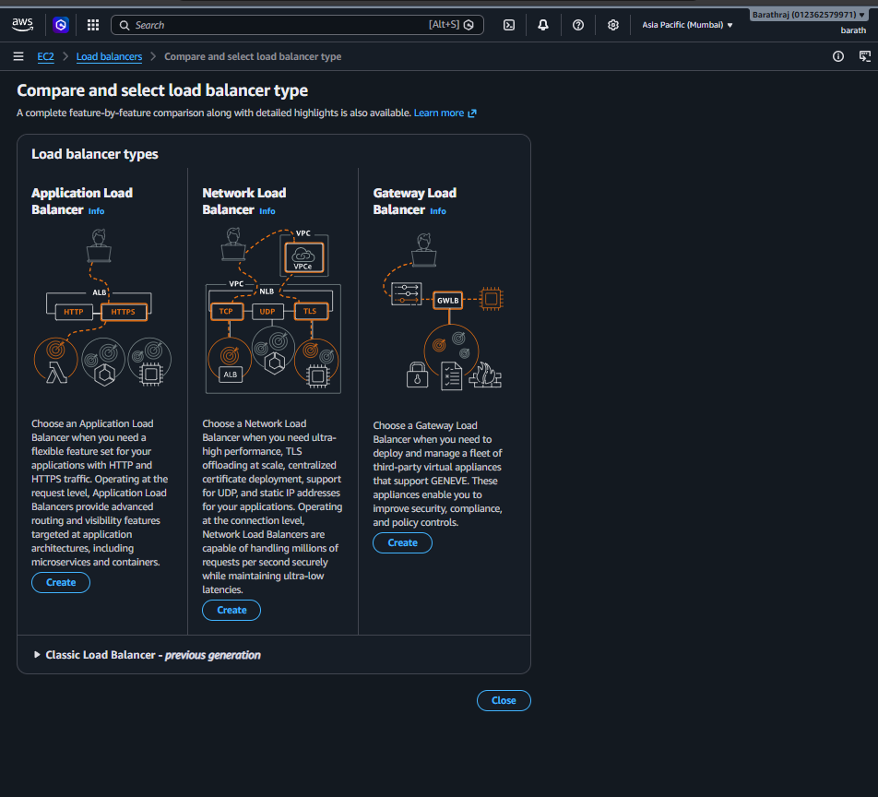
Create:
- Name: studentname-alb
- Type: Application Load Balancer
- Scheme: Internet-facing
Attach:
- Security Group (allow HTTP 80)
- Target Group: studentname-tg
- 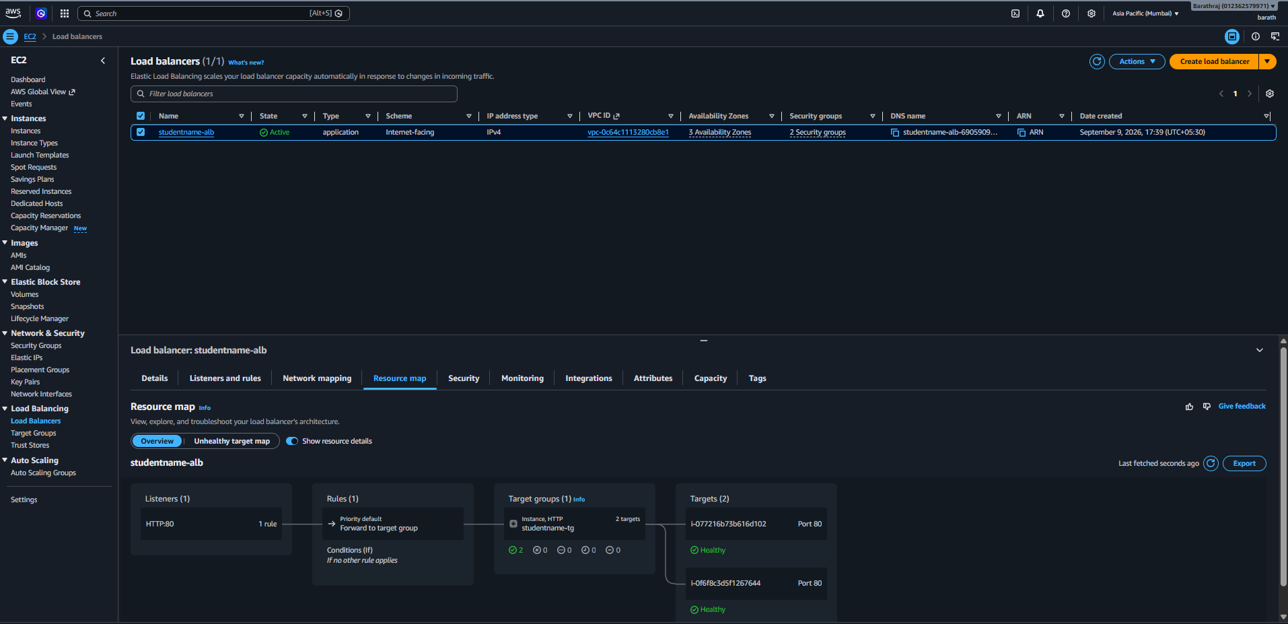

Step 8: Test Load Balancer
Copy ALB DNS:
http://studentname-alb-xxxx.amazonaws.com
✅ Refresh multiple times → should switch between Server 1 & Server 2
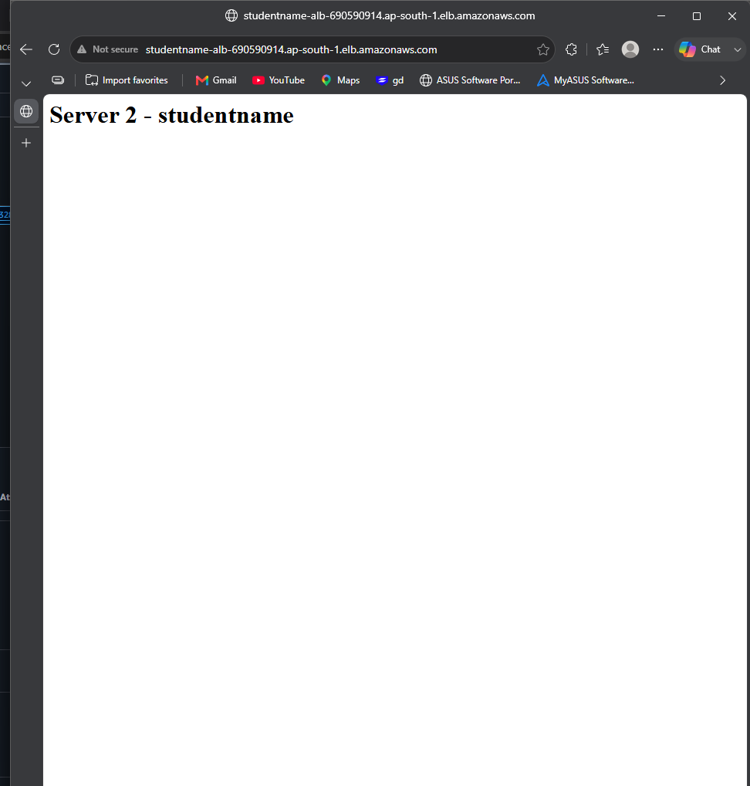
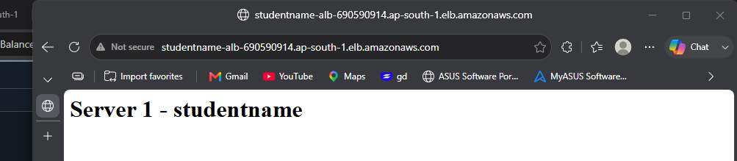

🌍 PART 3: Domain Setup (GoDaddy / Hostinger)
Buy domain from:
- GoDaddy
- Hostinger
Example:
studentname.com

🔗 PART 4: Direct Mapping (Without Route 53)
Step 9: Add A Record
- Type: A
- Name: @
- Value: Load Balancer DNS (or EC2 IP)
⚠️ Note: Some providers don’t allow ALB DNS in A record → use IP or skip
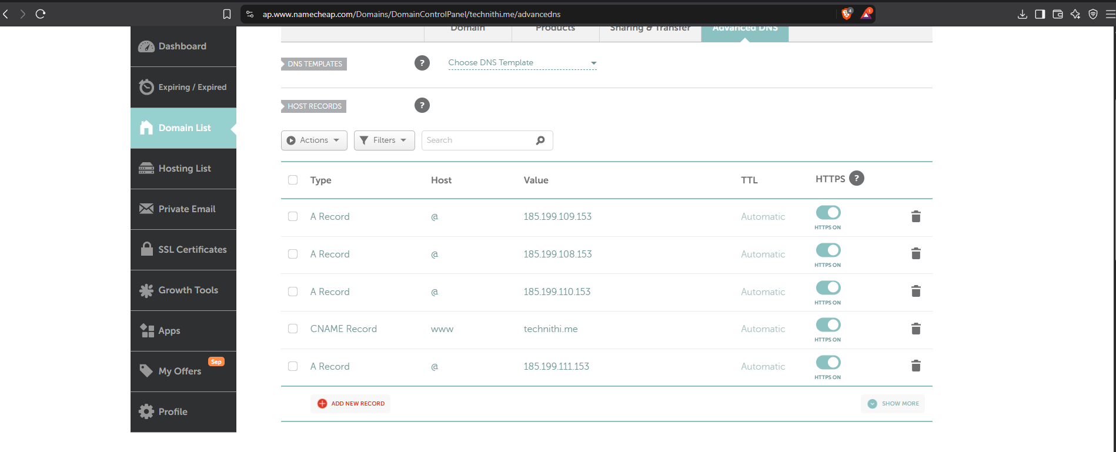

Step 10: Add CNAME Record
- Name: www
- Value: ALB DNS

Step 11: Test
http://studentname.com
http://www.studentname.com
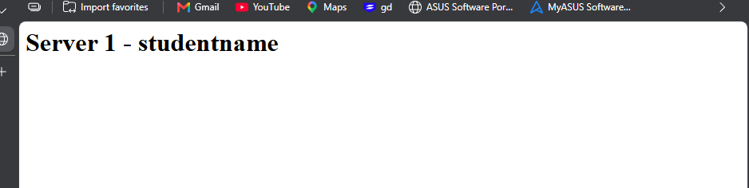

☁️ PART 5: Route 53 Setup
Step 12: Create Hosted Zone
Go to → Amazon Route 53
- Domain: studentname.com
- Type: Public Hosted Zone
- 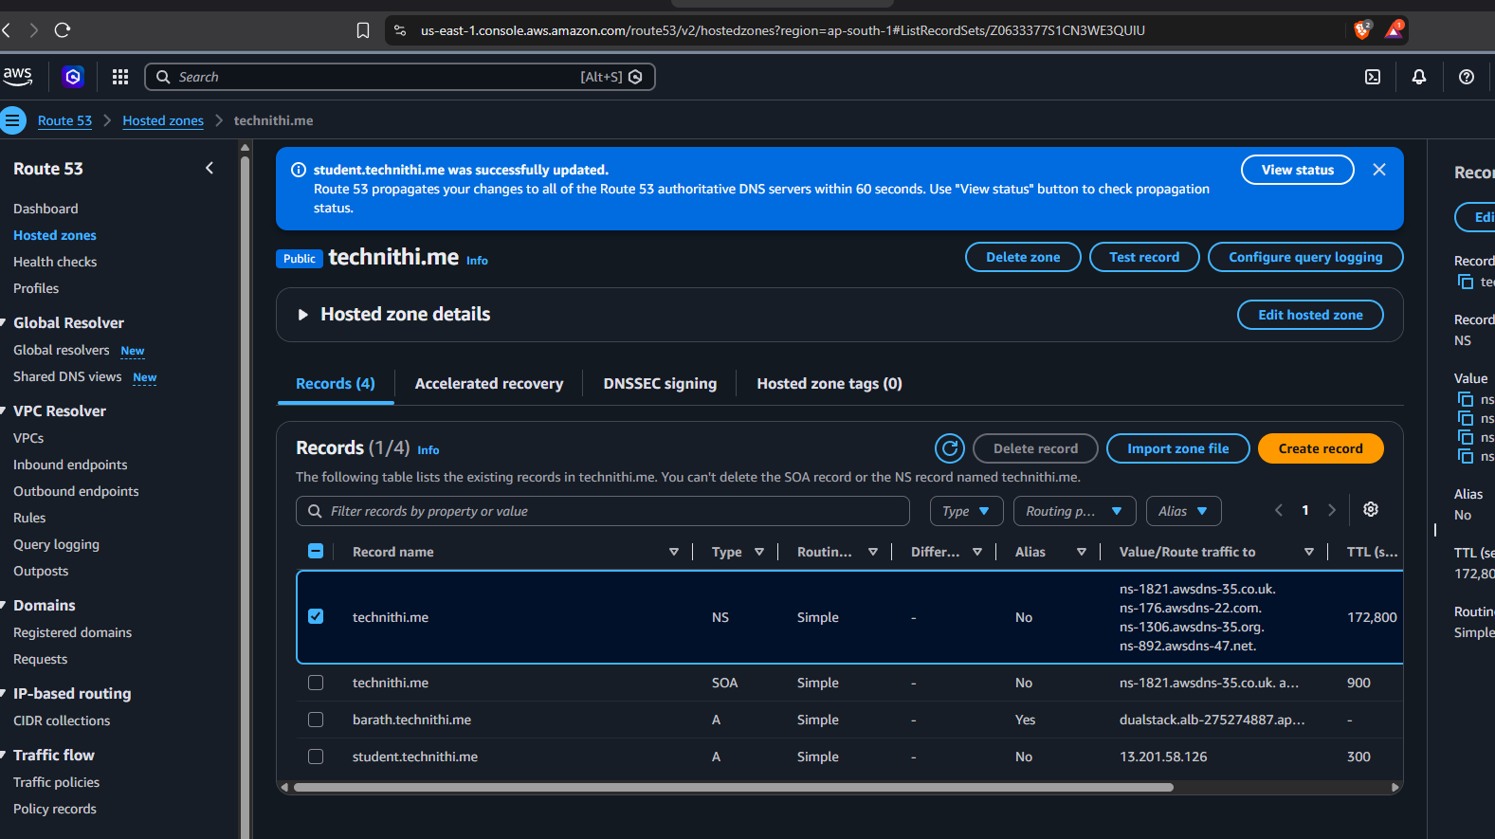

Step 13: Copy Name Servers
Example:
ns-123.awsdns-xx.com
ns-456.awsdns-xx.net

Step 14: Update Nameservers
In:
- GoDaddy
- Hostinger
Replace with AWS NS records
⏳ Wait for DNS propagation
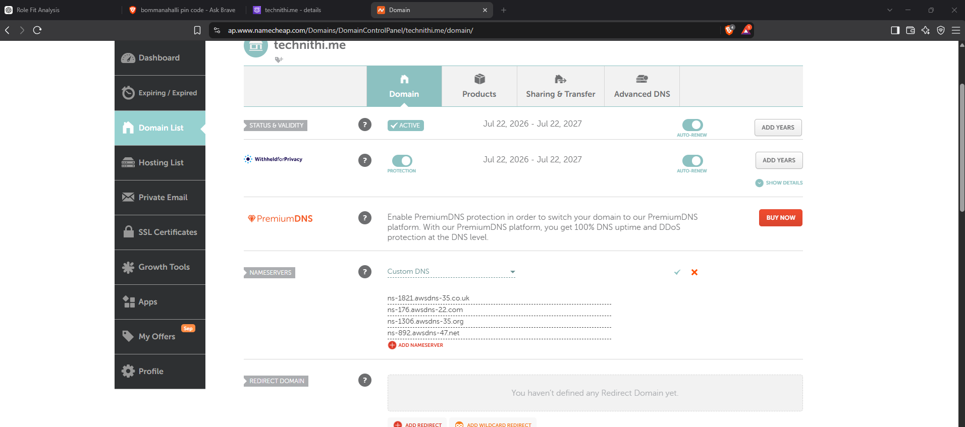

🌐 PART 6: Create Records in Route 53
Step 15: Create A Record (ALIAS)
- Type: A
- Name: (blank)
- Enable: Alias = YES
- Target: Load Balancer (studentname-alb)

Step 16: Create CNAME Record
- Name: www
- Value: studentname.com

✅ PART 7: Final Validation
Test:
http://studentname.com
http://www.studentname.com
✅ Should load via Load Balancer ✅ Refresh → traffic switches between servers
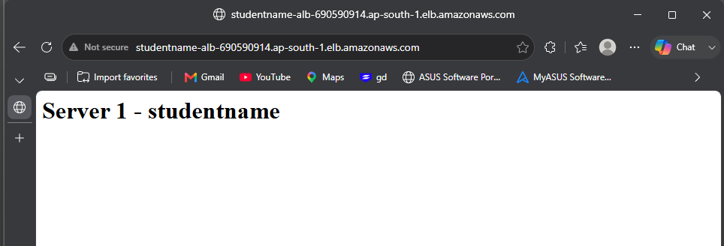

🔍 Verification Commands
nslookup studentname.com
dig studentname.com

🎯 Expected Outcome
Test | Result
EC2 Public IP | ✅ Working
Load Balancer DNS | ✅ Load balancing
Domain | ✅ Working
Route 53 Alias | ✅ Working

🧠 Bonus Tasks
- Enable HTTPS using ACM (SSL)
- Add Health Checks in Target Group
- Enable Auto Scaling
- Monitor using CloudWatch

📊 Architecture Flow
User Browser
↓
Domain (GoDaddy / Hostinger)
↓
Route 53 (DNS)
↓
Application Load Balancer
↓
EC2-1 EC2-2

